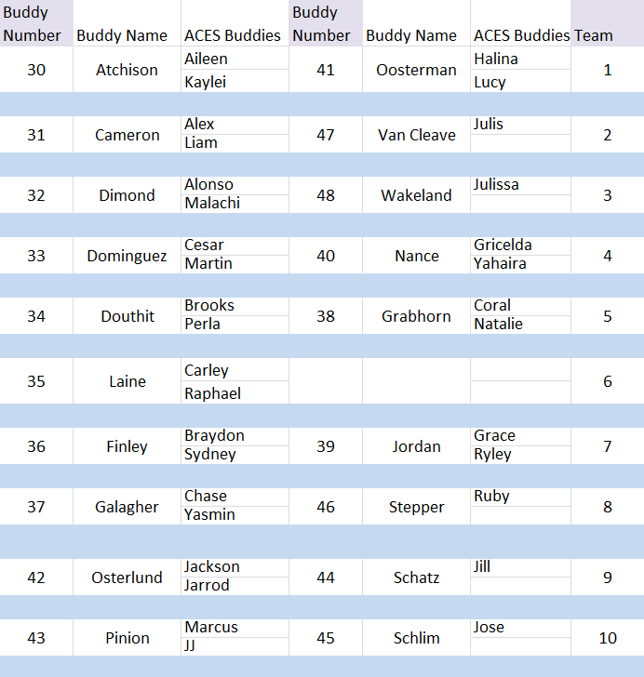

MS | 6 | 5 | 4 | 3 | 2 | 1
RS | 6 | 5 | 4 | 3 | 2 | 1
CR | 6 | 5 | 4 | 3 | 2 | 1
AC | 6 | 5 | 4 | 3 | 2 | 1
RE | 6 | 5 | 4 | 3 | 2 | 1
Buddy Number__________ Buddy Name_____________

MS | 6 | 5 | 4 | 3 | 2 | 1
RS | 6 | 5 | 4 | 3 | 2 | 1
CR | 6 | 5 | 4 | 3 | 2 | 1
AC | 6 | 5 | 4 | 3 | 2 | 1
RE | 6 | 5 | 4 | 3 | 2 | 1
Buddy Number__________ Buddy Name_____________

MS | 6 | 5 | 4 | 3 | 2 | 1
RS | 6 | 5 | 4 | 3 | 2 | 1
CR | 6 | 5 | 4 | 3 | 2 | 1
AC | 6 | 5 | 4 | 3 | 2 | 1
RE | 6 | 5 | 4 | 3 | 2 | 1
Buddy Number__________ Buddy Name_____________

MS | 6 | 5 | 4 | 3 | 2 | 1
RS | 6 | 5 | 4 | 3 | 2 | 1
CR | 6 | 5 | 4 | 3 | 2 | 1
AC | 6 | 5 | 4 | 3 | 2 | 1
RE | 6 | 5 | 4 | 3 | 2 | 1
Buddy Number__________ Buddy Name_____________

MS | 6 | 5 | 4 | 3 | 2 | 1
RS | 6 | 5 | 4 | 3 | 2 | 1
CR | 6 | 5 | 4 | 3 | 2 | 1
AC | 6 | 5 | 4 | 3 | 2 | 1
RE | 6 | 5 | 4 | 3 | 2 | 1
Buddy Number__________ Buddy Name_____________

